PROJECT DOCUMENTATION

AI WEATHER WISE

INTRODUCTION
- Project Title: AI WEATHER WISE
- Team ID : SWTID-2026-1491
- Team Leader: GUNASREE S & Mail id: sgunashree01@gmail.com

Team Members:
- HEMAVATHI M & Mail id: hemamahe2006@gmail.com
- NISHA S & Mail id: sagadevan3456@gmail.com
- SARASWATHI R & Mail id: saraswathiravii06@gmail.com

Project Overview:
AI Weather Wise is an AI-powered weather application developed to provide users with accurate and easily understandable weather information. The system allows users to register and securely log in before accessing the application features.
The application provides important weather details such as temperature, humidity, wind speed, and weather condition for a selected location. Along with normal weather information, the system uses Artificial Intelligence to generate a simple weather summary and provide useful recommendations based on the current weather conditions.
The main objective of the project is to convert raw weather information into meaningful and user-friendly information. This helps users understand the weather easily and make suitable decisions for their daily activities.

Main Features:
  - User Registration
  - User Login
  - Token-based Authentication
  - Location-based Weather Information
  - Temperature and Humidity Details
  - Wind Speed and Weather Condition
  - AI Weather Summary
  - AI Weather Recommendation
  - REST API-based communication

Architecture:
AI Weather Wise follows a client-server architecture in which the user interface communicates with the backend through REST APIs. The backend acts as the main processing layer between the user interface, weather service, database, and AI service.

Architecture Flow:
USER
↓
USER INTERFACE
↓
REST APIs
↓
┌──────────────┐
│ BACKEND │
└──────────────┘
↓ ↓ ↓

Authentication Weather AI
↓ ↓ ↓
Database Weather AI Service API
↓ ↓ ↓ RESPONSE
↓ UI

Architecture Components:
User Interface:
Provides screens for registration, login, weather search, and displaying weather and AI results.

Backend:
Receives requests from the UI, processes the request, communicates with required services, and sends the response back.

Authentication:
Handles user registration and login and generates an authentication token for protected API requests.

Weather Service:
Retrieves weather information such as temperature, humidity, wind speed, and weather condition.

AI Service:
Processes the weather information and generates human-readable summaries and recommendations.

Database:
Stores required user-related information and other application data.

Setup Instructions
Before setting up the AI Weather Wise project, the required development environment must be installed. The project requires Node.js and npm for running the backend application and managing dependencies.
A database must also be configured according to the project requirements. A code editor such as Visual Studio Code can be used for development, while Thunder Client or Postman can be used for API testing.
The required configuration values such as database connection details, authentication secret, weather API key, and AI API key are stored in the .env file.

Required Software
  - Node.js
  - npm
  - Database
  - Visual Studio Code
  - Thunder Client / Postman
  - Internet Connection

Technical Requirements
  - Frontend: User interface for interacting with the application
  - Backend: Handles authentication, weather processing, and AI requests
  - Database: Stores user and application-related data
  - Weather API: Provides current weather information
  - AI API/Service: Generates weather summaries and recommendations
  - Authentication: Bearer Token/JWT-based authorization
  - REST API: Used for communication between frontend and backend

Installation Steps:
The following steps are used to install and configure the AI Weather Wise application.

Step 1: Open the Project
Download or clone the AI Weather Wise source code and open the project folder in Visual Studio Code.

Step 2: Open Terminal
Open the terminal inside the project directory.

Step 3: Install Dependencies
Run the following command:

npm install
This installs all the packages and dependencies required by the application.

Step 4: Configure Environment Variables
Create or update the .env file with the required configuration values. PORT=5001
DATABASE_URL=your_database_url JWT_SECRET=your_secret_key WEATHER_API_KEY=your_weather_api_key AI_API_KEY=your_ai_api_key

Step 5: Start the Application
Run:
npm start or:
npm run dev
The application will start on the configured local server.

Folder Structure
The project is organized into different folders so that each component has a separate responsibility.

AI-Weather-Wise/
│
├── controllers/
│ ├── authController
│ ├── weatherController
│ └── aiController
│
├── routes/
│ ├── authRoutes
│ ├── weatherRoutes
│ └── aiRoutes
│
├── models/
│ └── userModel
│
├── middleware/
│ └── authentication
│
├── services/
│ ├── weatherService
│ └── aiService
│

├── config/
│ └── database
│
├── .env
├── package.json
├── server.js
└── README.md

Folder Description Controllers:
Contains the main application logic for authentication, weather, and AI operations.

Routes:
Defines the API endpoints through which the frontend communicates with the backend.

Models:
Defines the structure of data stored in the database.

Middleware:
Handles authentication, authorization, and request processing.

Services:
Contains external weather API and AI-related processing logic.

Config:
Contains database and other application configuration settings.

.env:
Stores sensitive configuration values such as API keys and database credentials.

server.js:
Acts as the main entry point for starting the backend server.
Note: The folder names above should match the actual project source code before final submission.

Running Application
After completing the installation and configuration, the application can be started using the following command:

npm start
For development mode, the following command can be used:

Npm run dev
Once the server starts successfully, the application can be accessed through the configured localhost port.

Example:
http://localhost:5001
The APIs can be tested using Thunder Client or Postman. Important API Operations

User Registration
POST /api/auth/register
Used to create a new user account.

User Login
POST /api/auth/login
Used to authenticate an existing user.

Weather API
GET /api/weather/Chennai
Used to retrieve weather information for a location.

AI Recommendation
POST /api/ai/weather-recommendation
Used to generate recommendations based on weather conditions.

AI Summary
POST /api/ai/weather-summary
Used to generate a natural-language weather summary.

State Management:
State management is used to store and update important information while the user interacts with the application.

The system manages the user authentication state, authentication token, selected location, weather data, loading status, errors, AI recommendations, and AI-generated summaries.
When a user requests weather information, the UI sends a request to the backend. After receiving the response, the application updates the relevant state and displays the latest information to the user.
For example, when the weather API returns the temperature, humidity, wind speed, and condition, these values are stored and displayed in the weather interface. Similarly, AI-generated recommendations and summaries are updated when their respective API responses are received.

UI – User Interface
The user interface of AI Weather Wise is designed to be simple and easy to use. It provides users with the required weather information without making the interface complicated.

Registration and Login
The registration page allows new users to create an account by providing the required details. Existing users can use the login page to authenticate themselves and access protected features.

Weather Interface
The weather section displays important information such as:
  - City
  - Temperature
  - Humidity
  - Wind Speed
  - Weather Condition

For example, the tested Chennai weather output contains:
City: Chennai Temperature: 29.62°C Humidity: 74%
Wind Speed: 5.74 Condition: Clouds AI Interface
The AI section displays the generated weather summary and recommendation. This makes the raw weather data easier for users to understand.

Testing
Testing is performed to verify whether the different components of AI Weather Wise work correctly. Thunder Client/Postman can be used to test the backend REST APIs.

Testing Areas
Registration Testing:
Checks whether a new user can successfully register using valid details.

Login Testing:
Checks whether a registered user can log in using valid credentials.

Authorization Testing:
Checks whether the generated Bearer Token allows the user to access protected resources.

Weather Testing:
Checks whether the application correctly retrieves weather information for the requested location.

AI Testing:
Checks whether the system generates weather summaries and recommendations based on the provided weather data.

Test Results

Function | Expected Result | Result
Registration | User account created | Passed
Login | User authenticated | Passed
Authorization | Token accepted | Passed
Weather API | Weather data returned | Passed
AI Recommendation | Recommendation generated | Passed
AI Summary | Summary generated | Passed

The screenshots provided for the project show successful API responses such as
201 Created for registration and 200 OK for login and other tested operations.

Known Issues
Although the application performs the main required functions, it has some limitations.
The weather and AI features depend on external services, so the application requires a stable internet connection. If an external API is unavailable, slow, or returns incorrect/incomplete information, the application may not provide the expected result.
The accuracy of AI-generated summaries and recommendations also depends on the quality of the weather data provided to the AI service.
Other possible limitations include API rate limits, delayed responses from external services, and limited functionality in the current version of the application.

Future Enhancement
AI Weather Wise can be improved by adding several advanced features in future versions.

Possible Enhancements
  - 7-Day Weather Forecast: Provides weather information for upcoming days.
  - Automatic Location Detection: Detects the user's location automatically.
  - Weather Alerts: Sends alerts for heavy rain, storms, or extreme weather.
  - Push Notifications: Notifies users about important weather changes.
  - Weather History: Allows users to view previous weather information.
  - Multiple City Comparison: Allows users to compare weather conditions between different cities.
  - Weather Maps: Provides graphical weather information using maps and charts.
  - Voice Assistant: Allows users to ask weather-related questions using voice.
  - Mobile Application: The system can be developed as an Android or iOS application.
  - Advanced AI Prediction: AI can be enhanced to provide more personalized and context-aware weather recommendations.
  - Multi-language Support: Weather information can be provided in multiple languages.
These enhancements can make the application more interactive, accessible, and useful for everyday weather monitoring.

AI Integration
Artificial Intelligence is one of the major features of AI Weather Wise. The AI module receives weather-related information such as temperature, humidity, weather condition, and other available parameters and processes this information to generate meaningful results.

AI Weather Summary
The AI module converts numerical weather information into a simple natural-language description.

Input:
City: Chennai Temperature: 29.62°C Humidity: 74% Condition: Clouds

AI Output:
The system generates a simple explanation of the current weather, such as describing Chennai as cloudy with relatively high humidity and explaining the overall weather condition.

AI Weather Recommendation
The AI module also provides recommendations based on the current weather conditions.
For example, when the temperature and weather conditions are comfortable, the system can suggest that it is suitable for outdoor activities and provide appropriate clothing-related advice.

AI Processing Flow
Weather Data
↓
Temperature + Humidity
↓
Weather Condition
↓
AI Processing
↓
Weather Summary
+
Weather Recommendation

The main purpose of AI integration is to transform raw weather data into meaningful and easy-to-understand information. This makes AI Weather Wise more than a basic weather application by providing intelligent summaries and recommendations to users

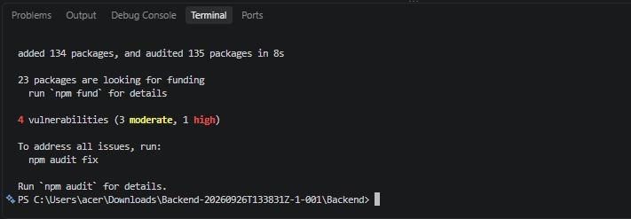
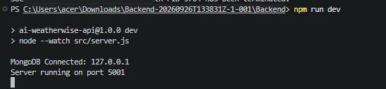
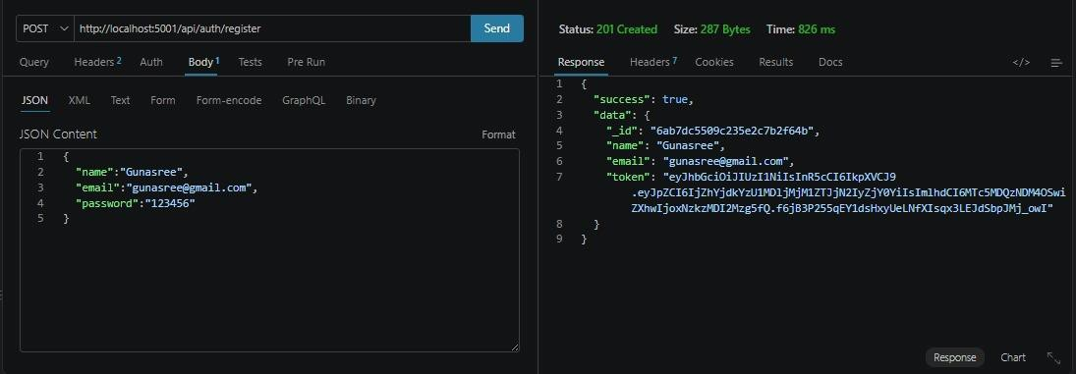
SCREENSHOTS



